KNN - K Nearest Node

**Step - 1) Choose the Number of k. Then, Do, Hit and trail. Start with 1, 2, .., 7.**

**Step 2 - Take Any random point/ Given Point and take Euclidean Distance.**

**Step 3 - Among all the Euclidean distance. Count the number of data point in Each Category or Cluster.**

**Ex :-**

**Random Point, P( X, Y ) -> (2, 5)**

**Any Random Point how many fall under category1, 2, ... , n**

**Step 4 - Assign the newly created point to winner Category.**

**Now, How do we Find the Euclidean Distance,**

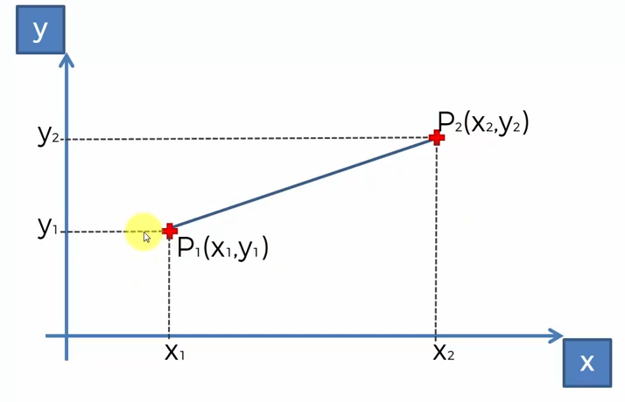

Let us consider, We two points and we have Co-Ordinates also and we want to find the distance between those 2 points.



**Let’s Consider Following Graph,**

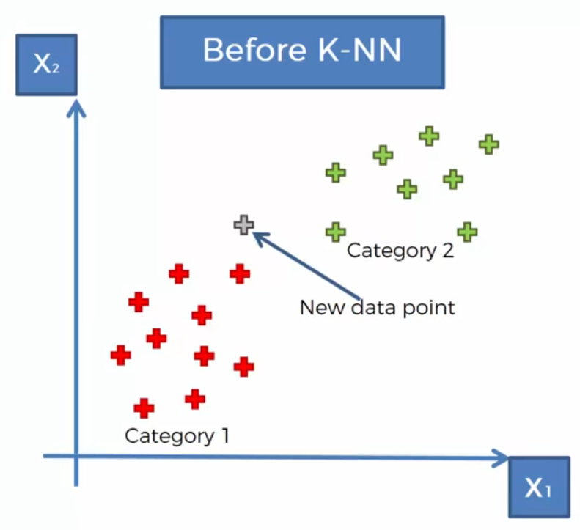

Category 1 and Category 2 are the 2 group/ Category/ Cluster. We have Considered a new point . Now, our job is to find that, this new point will fall into which group red group or green colour group.

Consider, We have a data set of 4 points in which each combination of X and Y points represents some class. Either True or False.

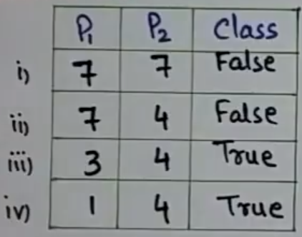

Now, Consider 1 point named as ‘P’ having x axis value as 3 and y value axis as 7. P -> ( 3, 7 )

Now, Our job is to find that, new point will come under True Category or False Category.

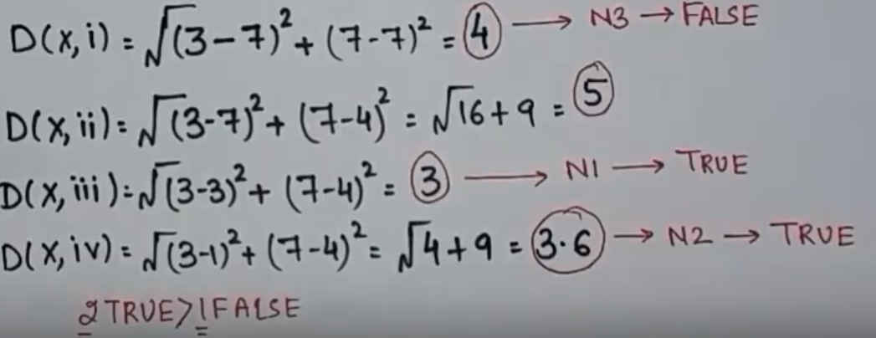

Now we will arrange the distance answer in ascending order and We will allot name of Each Data Set group.

3, 3.6, 4 , 5

Then, If it belong to True then, new Data also comes in category of 2.

Now, 3 is True, 3.6 is True and 4 False.

So, Among 3( **K = 3** ) -> 2 distance values are from True category and 1 is from False category.

So, Our new Data point is of group True.